Phone 701.352.0781
Fax 701.352.3043
e-mail: gracha@polarcomm.com
Grafton Area
Chamber of Commerce
___________________
Grafton Motor Vehicle
432 Hill Avenue
Grafton, ND 58237
www.graftonevents.com
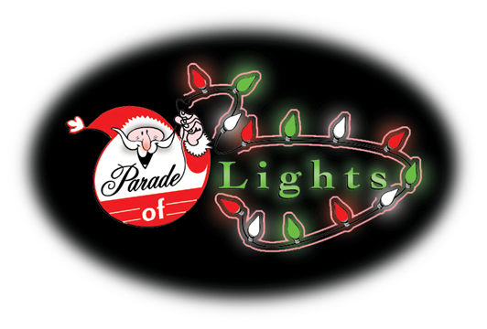
WinterFest Parade of Lights – Saturday, December 10th
The Grafton Area Chamber of Commerce would like to invite you to participate in the WinterFest Parade of Lights! It is scheduled to take place in Grafton on Saturday, December 10, 2016 beginning at 6:00 PM. Parade entrants may begin to assemble at the parking lot on the east side of the Life Skills & Transition Center at 5:00 PM. The parade route will be from 5th Street to Hill Avenue turning South on Hill Avenue and disbursing at 11th Street.
Note: Due to insurance liability as well as the concern for safety to our parade audience, the throwing of candy from a moving vehicle is prohibited. However, you may walk along the parade route close to the crowd and disperse candy if you so choose.
There is only one requirement for the parade – your entry must contain lights. MORE LIGHTS BRING MORE SMILES!
Please call the Grafton Area Chamber of Commerce at 701-352-0781 if you have any questions.
Please complete this form & return the bottom half of this page by December 2, 2016.
Grafton Area Chamber of Commerce
432 Hill Ave
Grafton, ND 58237
Email: gracha@polarcomm.com
Fax number: 701-352-3043
------------------------------------------------------------------------------------------------------------------------------------------
WinterFest 2016 Parade of Lights Entry Form
Entry Name: ____________________________________________________________
Contact Name: __________________________________________________________
Email: _________________________________________________________________
Mailing Address: ________________________________________________________
City: ________________________State: _________________Zip: ________________
Type of Entry (Please check): Float ____Color Unit ____ Political ____ Band ____
Machinery ____ Horses _____ Motor Vehicle ____ Youth ____ Other ____
Description: ____________________________________________________________
________________________________________________________________________

